Group 10 Final Project Report
"Multimedia Systems Lab, FAU-Intelligent and Collaborative Autonomous Robots for Real-Time Applications"
Group Members: John Angelo Sinfuego, Ian Simmons, David Uzan
Sponsors: Ashan Perera, Minghan Wei, Jefferson Charles

Abstract
This project will be mostly designed for industries that would need real-time object detection in multiple different environments. In this project, we will work with a cutting-edge autonomous robot named Uni-Go1. We will be integrating object detection technology through Uni-Go1 by applying our deep learning knowledge. This integration will allow Uni-Go1 to navigate through different environments and perform different tasks with precision that will be based on object detection

Table of Contents
List of Figures ............................................................................................................... Pg 3
I. Introduction ............................................................................................................... Pg 6
II. Scope of Work .......................................................................................................... Pg 7
III. Implementation Details ......................................................................................... Pg 9
IV. Conclusion .............................................................................................................. Pg 12
V. References ................................................................................................................ Pg 13

List of Figures
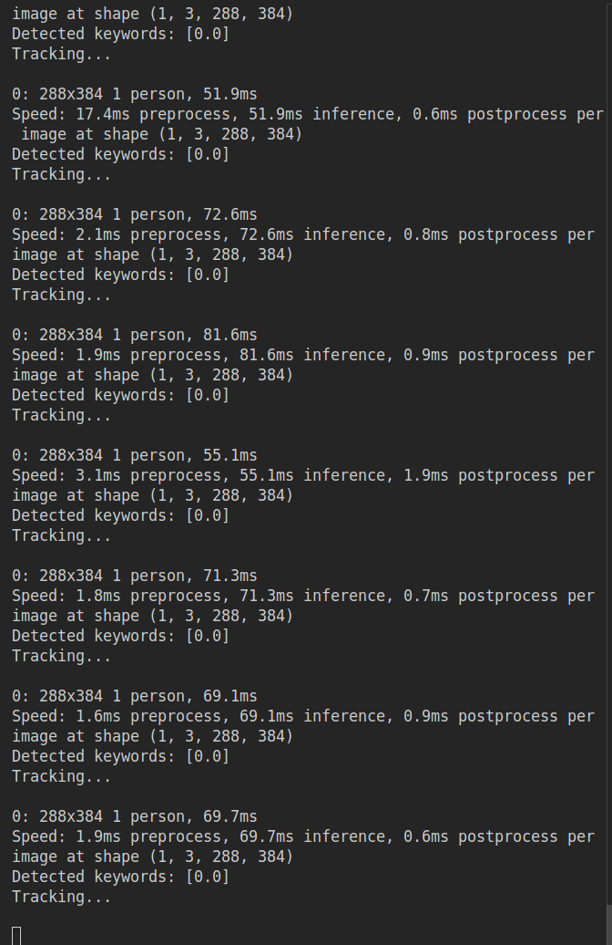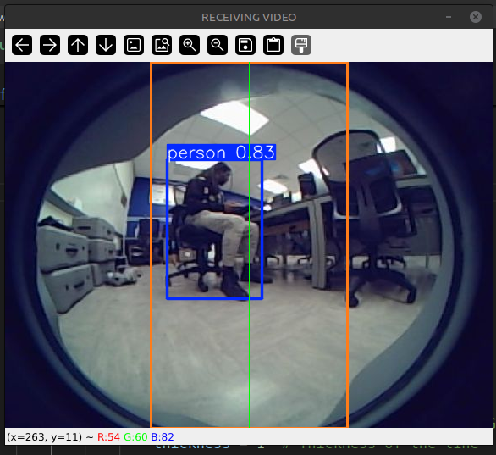
Top Figure: Feed from the code, details what is detected and response time.
Bottom Figure: From the front camera, a person is detected within the center threshold. No movement to be made.
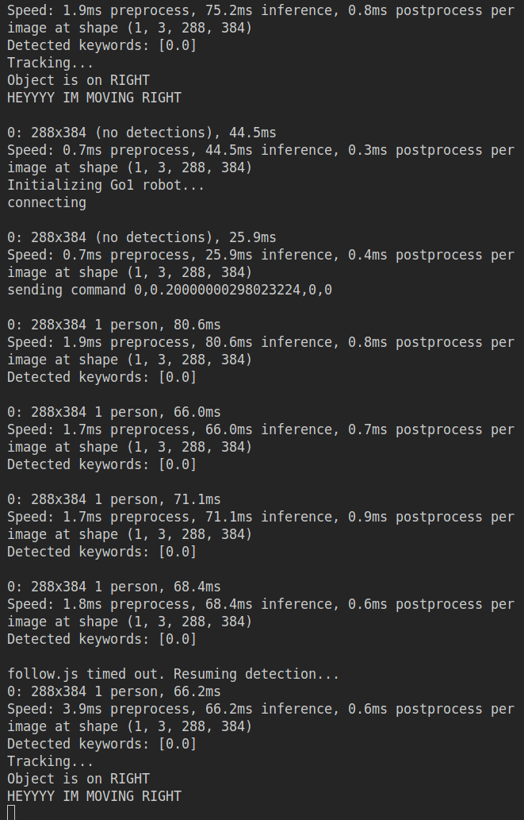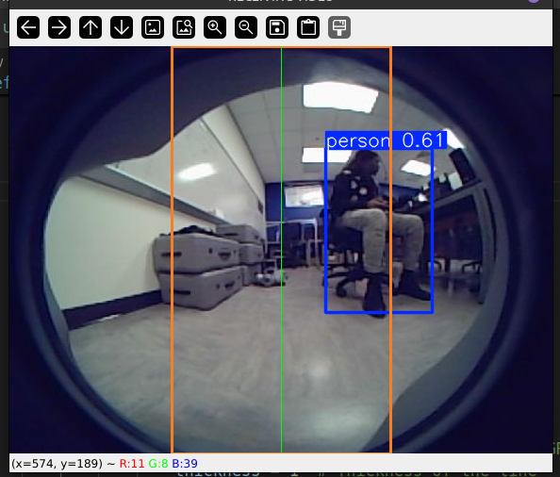
Top Figure: Feed details a person is detected outside of the center threshold and begins to call a movement command.
Bottom Figure: From the front camera, a person is detected to the right of the screen, outside of threshold. Movement commands are sent to center the person in frame.

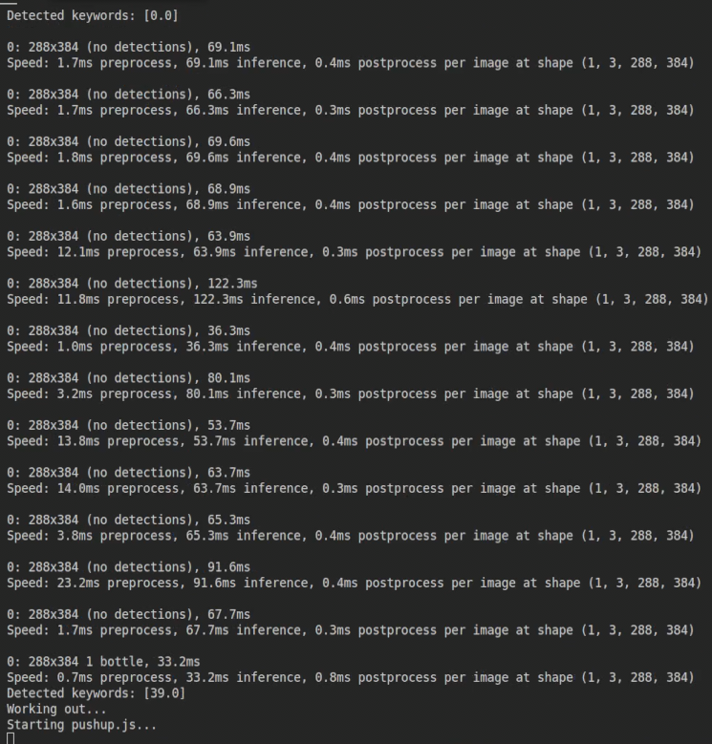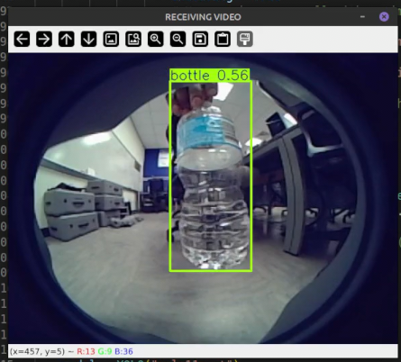
Top Figure: Feed details a bottle is detected and begins to call pushup commands.
Bottom Figure: From the front camera, a bottle is detected, commands are then sent to repeatedly make the dog crouch and stand up.

I. (John Sinfuego) Introduction
This proposal responds to an RFP from the following sponsors, Ashan Perera, Minghan Wei, and Jefferson Charles. The sponsors for this project aim for the project to be mostly designed for industries that would need real-time object detection in multiple different environments. In this project, we will work with a cutting-edge autonomous robot named Uni-Go1. We will be integrating object detection technology through Uni-Go1 by applying our deep learning knowledge. This integration will allow Uni-Go1 to navigate through different environments and perform different tasks with precision that will be based on object detection.

A. (John Sinfuego)I Background:
The sponsors for this project have previously worked on the same robot (Uni-Go1) in the past for different projects. Their experience on the robot is greatly beneficial to us working on the project who have no prior experience with Uni-Go1. The problem we are currently having is getting wi-fi to work with Uni-Go1, we need wi-fi to run the YOLOv8 repository to get live feed for object detection. The sponsors have tried to work on this in the past, stating that another group who worked on the robot got wi-fi up and running with the dog.

B. (John Sinfuego) Statement of the Problem:
The problem we have now is trying to get live camera feed from the dog as well as getting wi-fi to work with Uni-Go1. We need to get wi-fi to run YOLOv8 to get live feed for object detection. We also need to get the live camera running so we can stack the repository on top of the stream to enable object detection in real time.

II. Scope of Work
A. Overview: (David Uzan)
Our project is focused on the application of the Unitree-Go1 robot dog to operate autonomously based on factors in its environment. Our research stage focused on finding a simple object detection model that can run on recorded video and ultimately live video feed. We found YOLO and supporting documentation from Ultralytics, which is appropriate for early implementation and testing before applying more extensive and expensive models, we entered our design stage. Our design was fixed on detecting simple but easily distinguishable objects that are then used to trigger movement algorithms that are fit to the desired use case. Our code can identify the objects with relative confidence, but our movement algorithms are still in the research stage. We are yet to enter the final testing and calibration stage, but our plan for that is to find the best object detection model to run locally on the robot and fine tune its movement in tandem with its built-in obstacle avoidance to run smoothly.

B. Literature Review:
Some relevant research we gathered to advance this project include different repositories as well as some external websites to help advance our Uni-Go1 livestreaming capabilities. The main repository we found that was useful was the YOLOv8 repository for object detection. This repository will enable object detection for Uni-Go1 in real time. We also found some external links with information for CameraSDK which go over system architecture for Uni-Go1as well as some instructions on how to get live feed running from Uni-Go1.
S
C. Alternative Solutions: (David Uzan)
Solution 1:
Our first idea for a way to solve our problem was to have the robot constantly record and monitor the detections that are processed on its local hardware. This approach was taken under the impression that we could not have a reliable live feed from the robot’s cameras and that it could record its view to itself and run the object detection algorithm, to which it would then apply its proper movement case. A great restriction of this is the space the recordings take up in the local storage, as it would constantly have to be offloaded which could buffer server commands. Another weakness is the necessity to constantly call an extra algorithm that only increases run time and decreases reliability in field use.
Solution 2:
Our second idea for a solution was to the live feed from the robot’s cameras and apply object detection onto them directly. This removes the restriction for storage space on the robot, therefore reducing server buffers when there are multiple robots running and communicating at the same time. One oversight is the computational power to constantly run the object detection algorithms, as even if there is nothing detected in the cameras, the prolonged runtime of the system drains power quickly. This is the approach we are applying for this project, as it is the most applicable of the two, we have considered.

D. Evaluation: (David Uzan)
Our criterion for evaluating our design relies upon checking the accuracy and confidence of the detected objects, the wattage the robot outputs, runtime, and the temperature of the system. Since we will be using the NVIDIA Jetson Orin Nano, which is an additional processing unit for the robot, we also understand the economic implications and restrictions when it comes to reproducing our results and making large scale models. Sustainable runtime of the robot boils down to its wattage and temperature while running, as the more taxing the computations are, the shorter the system will be able to run for and give reliable output that is desired for its use cases. Besides the additional processor, all other hardware is accessible out of the box when receiving a Unitree-Go1 robot, which is also an expensive piece of equipment that makes reproduction even more scarce of a possibility.

E. Decision: (David Uzan)
Our evaluation process coincides greatly with our strongest solution, due to the minimization of using onboard storage and using less computational power, as both approaches detect the objects the same but one spends extra time taking and saving video. Both alternative solutions require mostly the same amount of computational power and expense, but the route we chose to take for the project uses the computational time as optimally as it can in comparison to the other. In the context of use cases for the robot, a couple of milliseconds could then be different, we cannot afford to use that to run more taxing models.

III. IMPLEMENTATION DETAILS – Ian Simmons

A. System Specifications and Functionalities
This project is heavily software based, utilizing Ubuntu we will be accessing the onboard devices of the Unitree Go1 to run a live camera feed back to our local device and incorporate our object tracking model to the camera process for object tracking. using Python we will condense the tracking model and decision making functions into a script that can be ran directly from the Raspberry Pi on board. while this is active our robot can operate autonomously
B. Overall System Design with Block Diagram(s)
Nano 1 contains the front facing camera, this is where we will send our feed from to be received on the Raspberry Pi attached to the dog. The Raspberry Pi will receive the live feed from the dog.
When our dog is running it broadcasts a WIFI network called “Unitree_######” with IP address 192.168.2.1. From there, we use secure shell protocol or SSH to remotely access the systems on board the Unitree Go1 from our local device (APP).
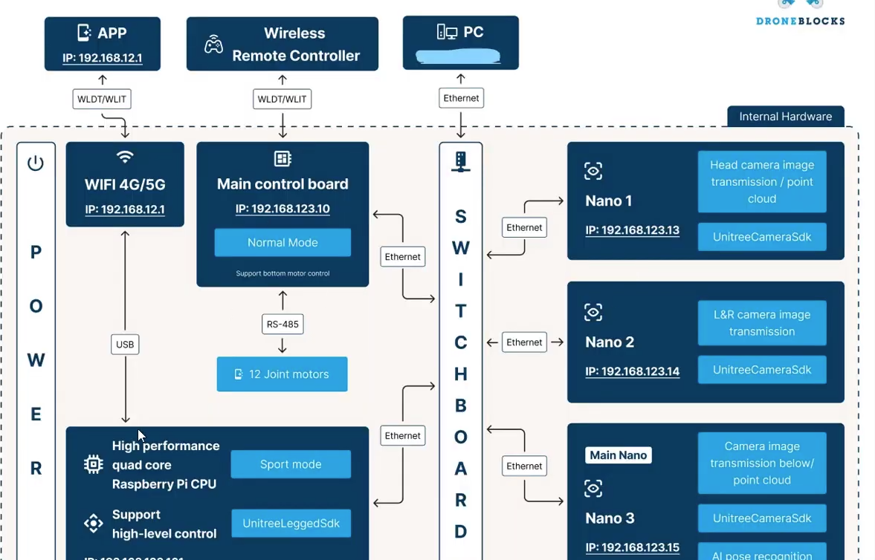

C. Circuit diagrams, Flowcharts and/or Use Case Diagrams
Case 1 - Follow
Live camera feed initiated
Object of interest located
Follow command initiated
Tracking active untill kill command recieved
Case 2 - Search
Live camera feed initiated
Object of interest located
Timestamp saved, alert sent and data saved
Live feed active untill kill command recieved
D. Technology and Technical Standards used

At the moment we are still in the process of developing our base case and being able to effectively run our model on the onboard Raspberry Pi of our dog. For testing purposes, we are going to first have our dog look at various items to test the performance of our model and the computing power of the Pi with YOLOv8 running. We will be evaluating how accurate our object identification model is and making necessary adjustments if need be and paying attention to the onboard diagnostics for tracking overall health.
Furthermore, we are using Ros to send commands to the dog to gauge the extent of What commands are possible for the dog to execute effectively period from there we were going to incorporate our own script based off the live tracking feed that will allow the dog to make decisions while operating. The accuracy of the decisions made based off the functions given, and the time it takes for an action to be carried out after an object is properly identified are part of the evaluation parameters.

E. Testing and Performance Evaluation
Our project statement had been derailed during the work process by the outside influences of the other projects going on in the lab, so towards the end of our tenure the promised Jetson Nano was unable to be used for our purposes. That being said, we improved our code so much so that the once 1400 millisecond delay between each frame became closer to 70-100ms, so the jetson would have been only a greater improvement. Since the project was delayed, we unfortunately had to spend more time on optimization of the system than creating more complex movement with the robot.
Once we had reliable access to the camera feed of the robot and could parse each of the objects being detected by the YOLO model embedded on its nanos, we set out movement tests with the Unitree NodeJS library. We have 3 separate movement functions when a specific object is detected: a simple forward movement, a pushup function where it loops the up and down movements, and a turning function where it turns to center a person detected on the extreme left or right of its vision.
The first two movements work without any issue, detecting people for the moving forward command and detecting a bottle of some sort for the pushup command. We tested both of those by walking around the front camera and holding bottles all around its field of view, changing the confidence level for the model as we got a better feel for what it can focus on specifically. The faults began to show in our turning command, as it would unreliably stream its turn left and right functions, making the robot move sporadically or not at all, in the wrong directions. We tested this by walking around the corner of its field of view and changing the bounds of detection areas, but to no avail.
Overall, our code can quickly take in object detection information and communicate that to movement commands, but more complex movements and computations tax the system and commands begin to override.

F. Discussions on Lessons Learned
Traversing the embedded systems for the robots, such as the nanos and raspberry pi, proved to be a deeply confusing and mundane task as there was always a storage problem as well as an imported library issue. Working with Unitree-Go1's unique system made it difficult to get acclimated to, but as time went on it became more comfortable. Using the YOLO model also made reading documentation easier and more effective as we became more understanding of what in particular we were looking for, as well as how to find it more efficiently. This project was a great learning experience for understanding system structures, communication of parts in embedded systems, and how we can create programs to work in tandem with all of those sections of the system for an even more robust application.

IV. CONCLUSION
In conclusion, the Uni-Go1 project has demonstrated significant advancements in real-time object detection capabilities within autonomous robotics. By integrating YOLOv11 for object recognition, we will enable Uni-Go1 to perform tasks with enhanced precision and adaptability in various environments. Despite challenges such as ensuring stable Wi-Fi connectivity and optimizing computational performance on limited hardware, we will create a foundation for Uni-Go1 to operate effectively with live camera feeds and real-time decision-making.

V. REFERENCES
https://unitree-docs.readthedocs.io/en/latest/get_started/Go1_Edu.html

https://techshare.co.jp/faq/unitree/%e3%80%90unitree-go1%e3%80%91%e9%a0%ad%e9%83%a8%e3%82%ab%e3%83%a1%e3%83%a9%e3%81%ab%e3%81%8a%e3%81%91%e3%82%8bunitreecamerasdk%e3%81%aeexample%e5%ae%9f%e8%a1%8c%e6%96%b9%e6%b3%95.html

https://github.com/ICE9-Robotics/ice9_unitree/wiki/Unitree-camera#disable-individual-items

https://github.com/unitreerobotics/UnitreecameraSDK/issues/3
https://github.com/unitreerobotics/UnitreecameraSDK/pull/5
https://github.com/unitreerobotics/UnitreecameraSDK/issues/6

